ALLOWAY STATE SCHOOL
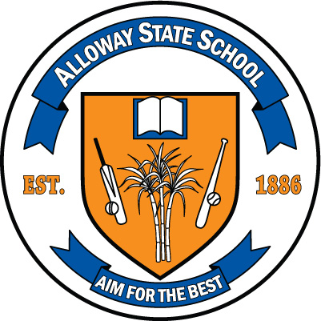

4334 Goodwood Road Bundaberg Q 4670
(07) 4159 7352
Fax (07) 4159 7508
Email: admin@allowayss.eq.edu.au
Web: www.allowayss.eq.edu.au

STUDENT DRESS CODE
Alloway SS has a very distinctive official school uniform incorporating base colours of Royal blue and orange. Students are required to wear this uniform when:
- Attending or representing the school;
- Travelling to and from school; and
- Engaging in school activities out of school hours
- Shirts must be tucked in
Shirts and hats are available from the school:

- Uniform Shirts - $28 (all sizes)
- Wide brimmed hat - $7.00
- Legionnaire hat - $5.00

CLOTHING OPTIONS:
- School polo shirt
- Royal blue skort, shorts, skirt, trousers
- Royal blue rugger shorts
- Royal blue mesh shorts
- School jumper/tracksuit - Royal blue only
- SHOES - Enclosed shoes are compulsory. Black is preferred with white/black socks. Sports shoes are ideal.
- HAT – royal blue, wide brimmed hat or legionnaire to be worn at all times when outdoors.
- JEWELLERY – jewellery is not to be worn to school. Students are permitted to wear a watch and/or studs or sleepers, only in ears, maximum of 2.)
Items which could cause injury to the wearer or others in a sporting context must be removed before the child participates and remain the responsibility of the student.
- MAKE-UP – is not permitted.
- NAIL POLISH – is not permitted
- HAIR – shoulder length or below needs to be tied back.

NON-COMPLIANCE
- Exemption process – parents are to communicate with the school in the instance that their child is unable to comply with the student dress code
- Alternative arrangements – the principal may approve these for a set period of time upon written request from the parent
- Clothing bank – the school may offer the use of relevant items from a bank of second hand items held at the school
- Sanctions – imposed on once only basis per episode of non-compliance. These reflect the severity and recentness of the non-compliance and are limited to one of the following:
- Withdrawing the student from the playground
- Preventing a student from attending, or participating in, any activity for which the student is representing the school; or
- Preventing the student from attending or participating in any school activity that is not an essential school educational program

The P & C of Alloway State School resolves that it supports a student dress code for Alloway State School because it believes that a student dress code at Alloway State School promotes objectives of Education [General Provisions] Bill 2006.
In particular, the P & C of Alloway State School supports the intention of a student dress code in providing a safe and supportive teaching and learning environment by:
- Ready identification of students and non-students at school;
- Eliminating distraction of competition in dress and fashion at school;
- Fostering a sense of belonging; and
- Developing mutual respect among students through minimising visible evidence of economic or social difference

Relevant legislation and policy
Legislation and/or regulations
- Anti-Discrimination Act 1991 new window Part 2, Division 7(1); Division 3, 39; Chapter 3, Part 1, 117(1)(2); Part 2, 118 http://www.legislation.qld.gov.au/LEGISLTN/CURRENT/A/AntiDiscrimA91.pdf
- Education (General Provisions) Act 2006 new window Sections 360-363, section 283 http://www.legislation.qld.gov.au/Bills/51PDF/2006/EducGenProvB06.pdf
- Workplace Health and Safety Act 1995 new window Division 2, 28; Division 3, 36 http://www.legislation.qld.gov.au/LEGISLTN/CURRENT/W/WorkplHSaA95.pdf
- Disability Discrimination Act 1992 new window Part 2 Division 2, 22 and Division 3, 37-38 http://www.comlaw.gov.au/ComLaw/Legislation/ActCompilation1.nsf/0/31452800B62A28B7CA256FC00020014A/$file/DisabilityDiscrimination1992_WD02.pdf
- Racial Discrimination Act 1975 new window Part II, 9 (1), (1A) http://www.comlaw.gov.au/ComLaw/Legislation/ActCompilation1.nsf/0/29DCCB9139D4CCD8CA256F71004E4063/$file/RDA1975.pdf
- Sex Discrimination Act 1984 new window Division 2, Section 21 http://www.comlaw.gov.au/ComLaw/Legislation/ActCompilation1.nsf/0/3A1AE1C157596F93CA2571410005BFEF/$file/SexDiscrimination84_WD02.pdf
Related procedures
- SMS-PR-021: Safe, Supportive and Disciplined School Environment /strategic/eppr/students/smspr021/
- FNM-PR-004: Purchasing Textile Clothing and Footwear /strategic/eppr/finance/fnmpr004/
- HLS-PR-013: Developing a Sun Safety Strategy /strategic/eppr/health/hlspr013/
- HLS-PR-012: Curriculum Activity Risk Management /strategic/eppr/health/hlspr012/
- LGS-PR-005: Trade Practices /strategic/eppr/legal/lgspr005/
- CRP-PR-009: Inclusive Education /strategic/eppr/curriculum/crppr009/

